**MySQL database setup:**

Create a schema with name **internship** and then create a table with name **registration** with column email, **phonenumber, firstname, lastname, collegename, residentialaddress, city, postalcode, state_region, dob, highesteduation, mentorname, photoid, studentid, marksheet** by running below sql script.

CREATE TABLE `registration` (

`email` varchar(300) DEFAULT NULL,

`phonenumber` varchar(100) NOT NULL,

`firstname` varchar(100) DEFAULT NULL,

`lastname` varchar(100) DEFAULT NULL,

`collegename` varchar(500) DEFAULT NULL,

`residentialaddress` varchar(100) DEFAULT NULL,

`city` varchar(100) DEFAULT NULL,

`postalcode` varchar(50) DEFAULT NULL,

`state_region` varchar(100) DEFAULT NULL,

`dob` varchar(100) DEFAULT NULL,

`highesteduction` varchar(300) DEFAULT NULL,

`photoid` blob,

`studentid` blob,

`marksheet` blob,

`mentorname` varchar(100) DEFAULT NULL,

PRIMARY KEY (`phonenumber`)

) ENGINE=InnoDB DEFAULT CHARSET=utf8mb4 COLLATE=utf8mb4_0900_ai_ci;

**Code setup:**

1. Install eclipse IDE from the given link <https://www.eclipse.org/downloads/>
2. Extract Project file.zip and inside this we have candidateRegistration project, import this project in eclipse IDE.
3. Open registerDao.java and change localhost port and database username and password of your configurations at place mentioned in screenshot.

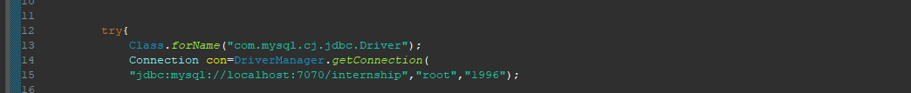

1. After making this changes, right click on project then go to Build path then configure build path and then go to Libraries and click on Modulepath and select Add External JARS and load MySQL connector jar which is present in Project file folder which was extracted earlier.

**Build Path->Configure Build path->Libraries->Modulepath->Add External JARS->MySQL Connector jar**

1. After loading Jars, click on Classpath and click on Add Library and select Server Runtime and select Apache-tomcat-10.1.12 and install in your system.

**Build Path->Configure Build path->Libraries->Classpath->Add Library->Server Runtime->Apache->Apache-tomcat-10.1.12**

1. Right click on project and select Run as then click on Run on Server, and your setup is completed.